Project Design Phase
Solution Architecture

Date | 15 February 2026
Team ID | LTVIP2026TMIDS24884
Project Name | Heart Disease Analysis
Maximum Marks | 4 Marks

Solution Architecture:
The Solution Architecture of the Heart Disease Analysis System bridges the gap between the healthcare problem (difficulty in analyzing heart disease risk patterns) and the technological solution (interactive analytical dashboard system).
The architecture defines how different components such as user interface, backend logic, database, and visualization tools interact to provide accurate, secure, and scalable health data analysis.

Example - Solution Architecture Diagram:

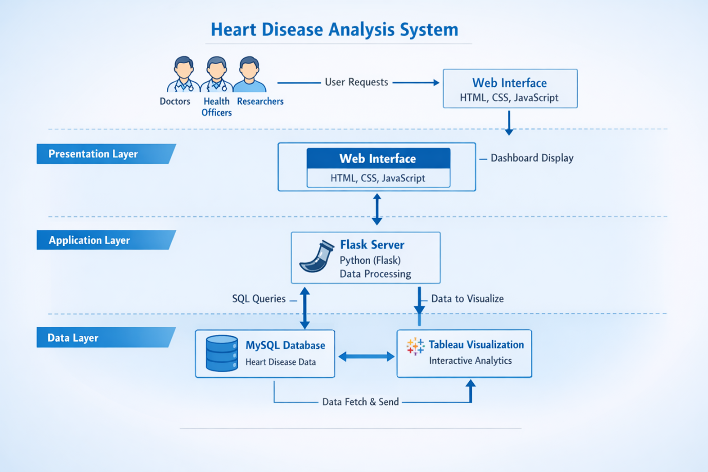
Figure 1: Architecture and data flow of the voice patient diary sample application
Reference: https://aws.amazon.com/architecture/

